Home Page

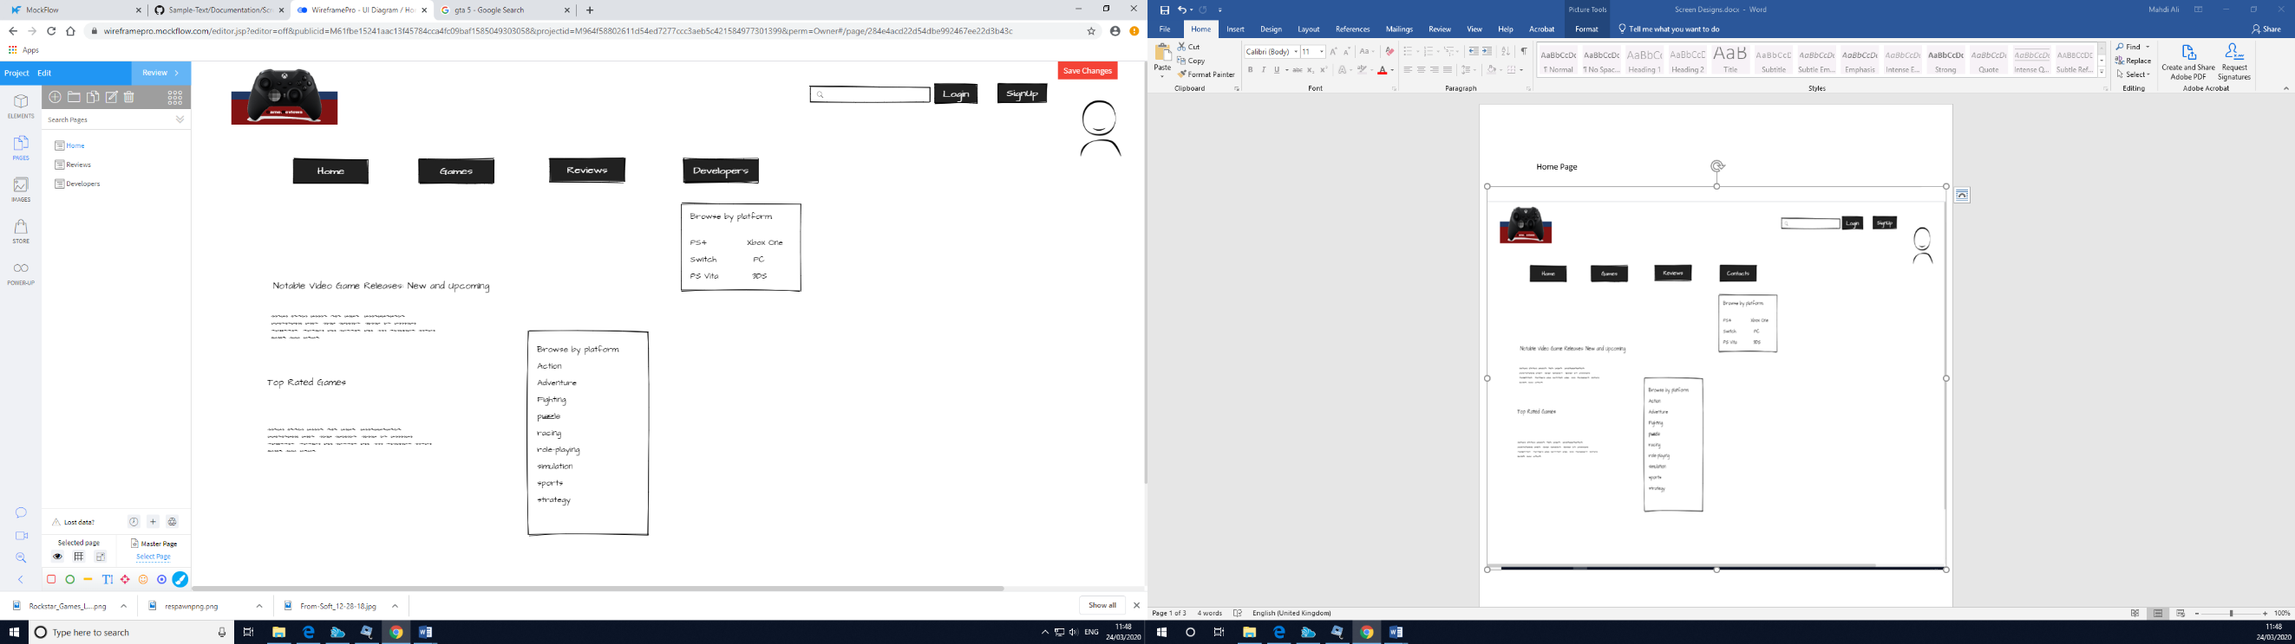

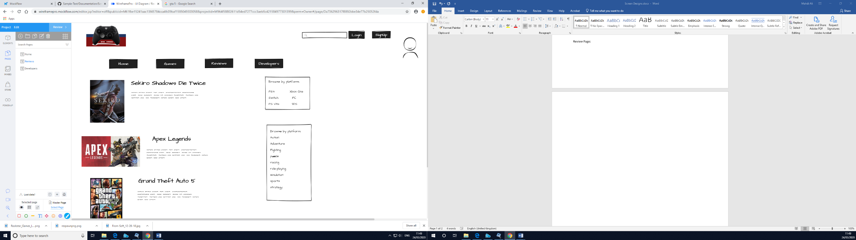Review Page:

Developers Page:

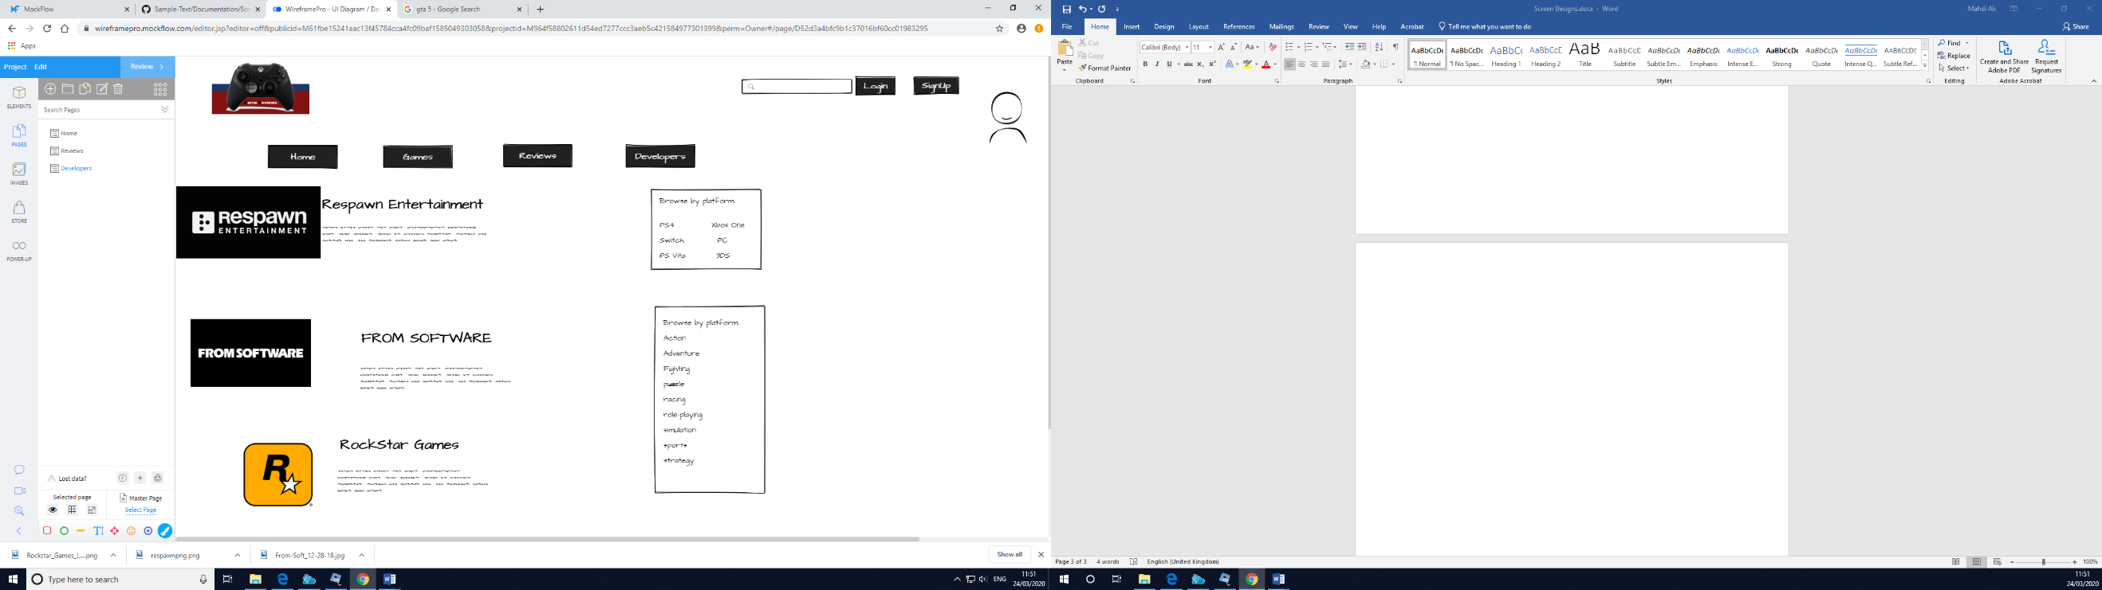

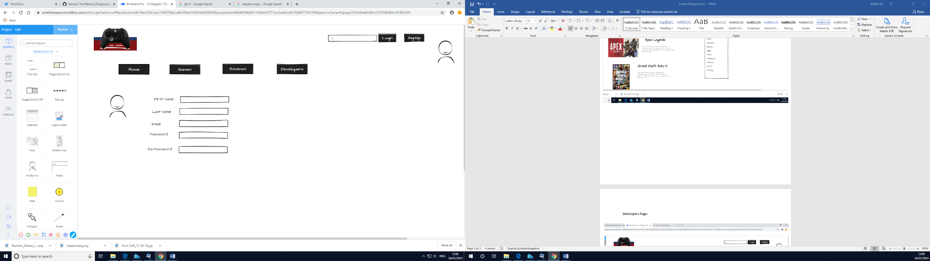Register Page: